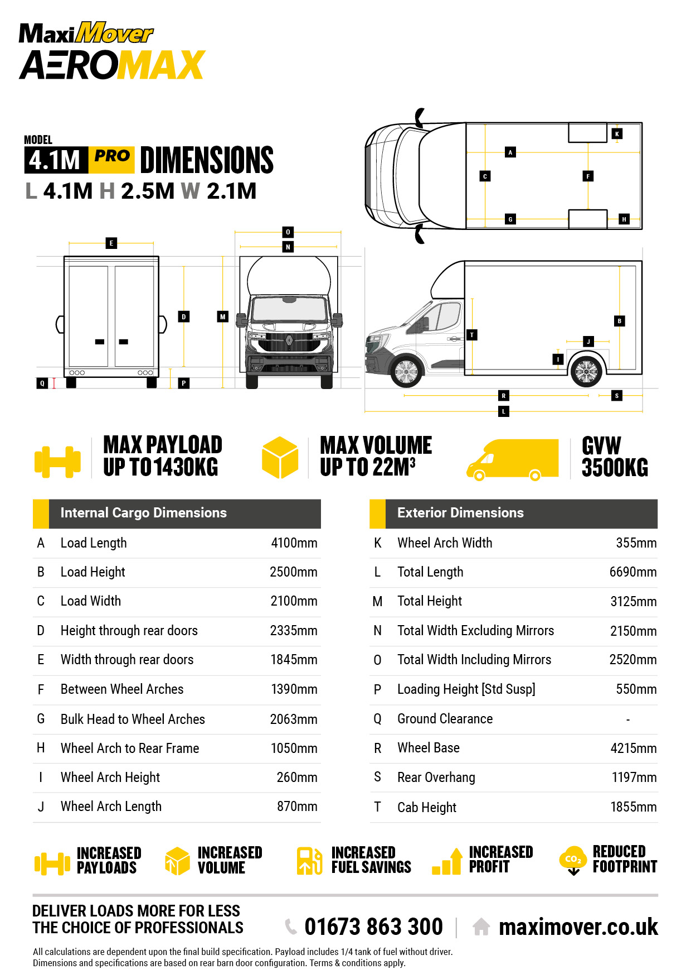

|  |
| --- |
| {ClientLogo} |

**Factory Direct Quotation No: {QuotationNumber}**